**DC Output Power Supply with Current Limit**

(jas, DC Output Power Supply Project.docx, 4/10/2024)

Contents

Introduction 1

Parts and Materials 2

Recommended Procedure 4

Calculations 5

Performance Characterization 9

Initial Power-Up 9

Output Voltage Regulation and Current Limit 10

Voltage Ripple and Ripple Rejection 12

Performance Summary 15

Project Report 15

Project Report Grading Rubric 17

# Introduction

Our ECEN 350 project is to design and construct a fixed **DC Output Power Supply** with a current limit that can be either AC or DC powered. You are to choose the DC output voltage of your power supply, within the range of 2.5 to 9.0 V. **You are to individually complete the calculations, schematic, performance characterization and accompanying report for this project**. Many job interviews involve detailed technical questions regarding student projects such as this one. So striving to understand the details of your project and then clearly documenting those details in a well written report may help get you the job you want. For this project, project 20% of your grade is determined by the submission of the document **DC Output Power Supply Calculations Summary**, with the remaining 80% determined by a Project Report, as described in the appropriate DC Output Power Supply Project Instructions.

# Parts and Materials

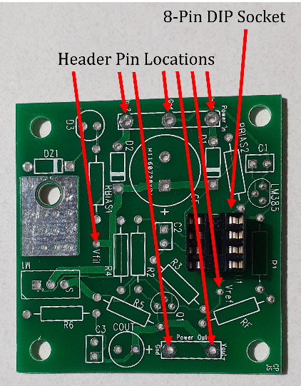A custom printed circuit board (PCB) developed for this DC Output Power Supply Project is illustrated in **Figure 1**. The figure shows the component side of the PCB, with solder joints to occur on the opposite side. Also shown in **Figure 1** is an 8-pin DIP socket for the dual op-amp, aiding in debug if necessary. In addition, **Figure 1** illustrates the mounting holes for seven long header pins that provide connection points for test leads on the fully assembled PCB.

**Figure 1:** Custom PCB for DC Output Power Supply Project with DIP Socket Installed and Header Pin Locations Illustrated.

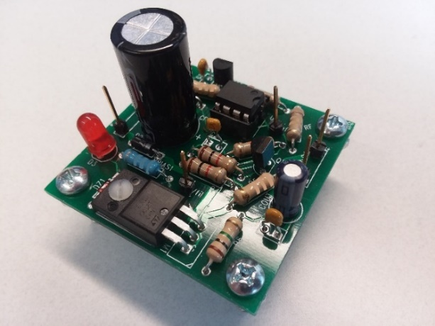An example of a completed DC Output Power Supply using the custom 2-layer PCB is illustrated in **Figure 2**. Note that the long header pins are installed with the long side on the component side, providing convenient connection points for test leads.

**Figure 2:** Top Side of a Constructed DC Output Power Supply Using the Custom PCB.

It is recommended that the long header pins be the last items soldered onto the PCB. Yet, soldering the long header pins onto the PCB can be challenging, as they will not stand up straight on their own. Hence, the Solder Fixture shown below in **Figure** 3 is to be used to hold the long header pins in place for soldering.

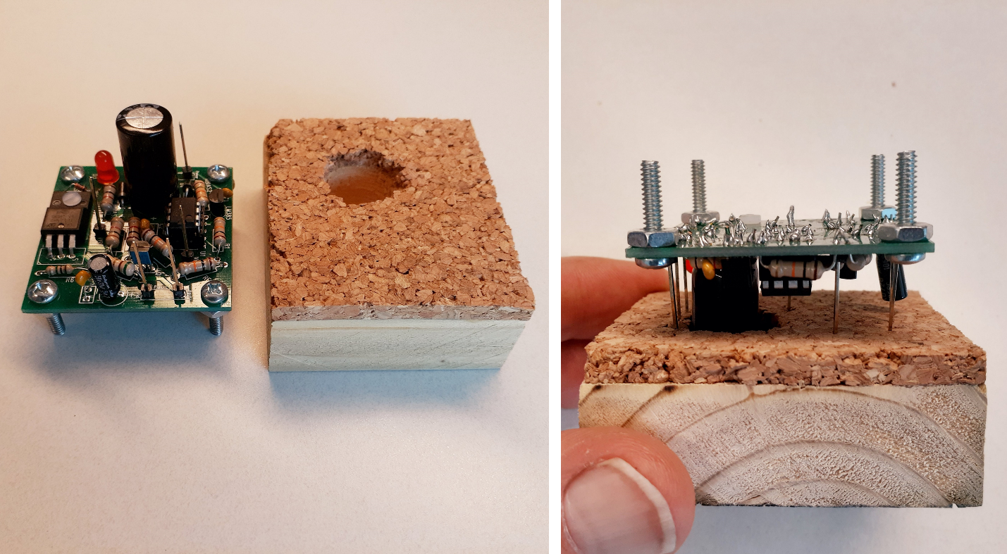

**Figure 3**: Solder Fixture to Hold the Long Header Pins for Soldering.

The parts needed for this power supply project are given below in **Table 1**. Notice that a nylon screw and nut are used to bolt down the power transistor, providing for solid mounting and improved thermal resistance. While much of the circuit design along with the overall implementation for this project has been provided, some design decisions remain for you to complete. You are to choose the component values not given in **Table 1**, as explained further in this document. After completing your determination of all components, you are to construct a soldered version of your power supply, like the one illustrated in **Figure 2**. Then upon completion of the construction you are to characterize the performance of your power supply, followed by writing and submitting a report documenting your efforts.

**Table 1:** Parts List and Description for the DC Output Power Supply.

|  |  |  |
| --- | --- | --- |
| **Quantity** | **Part Description** | **Location** |
| 1 | 2-Layer Custom PCB | STC 215 |
| 1 | 100 V N-Channel MOSFET in TO220 Package (STF80N10F7 or AOTF296L) | STC 215 |
| 1 | LM358N Dual Op-amp | STC 215 |
| 1 | 8-pin DIP socket for Dual Op-amp. | STC-215 |
| 1 | LM385-2.5, 2.5 V Voltage Regulator Diode | Engineering Lab Stock |
| 1 | 12V Zener Diode | Engineering Lab Stock |
| 2 | 1N4007 Diodes | Engineering Lab Stock |
| 1 | 2N3904 npn transistor | Engineering Lab Stock |
| 1 | 22 µF 50 V Aluminum Electrolytic Capacitor | Engineering Lab Stock |
| 2 | 0.1 µF Ceramic Capacitor (bent leg) | Engineering Lab Stock |
| 1 | 0.01 µF Ceramic Capacitor | Engineering Lab Stock |
| 1 | Red Power Indicator LED | Engineering Lab Stock |
| 1 | 2-56 x 3/8 inch screw for mounting MOSFET. | Engineering Lab Stock |
| 1 | 2-56 nut for mounting MOSFET. | Engineering Lab Stock |
| 4 | 6-32 x 5/8 inch screws for PCB Legs. | Engineering Lab Stock |
| 4 | 6-32 nuts for PCB Legs. | Engineering Lab Stock |
| 7 | Header pins for convenient test lead connection. | Engineering Lab Stock |
| 1 | 1000 uF capacitor | Engineering Lab Stock |
|  |  |  |
| 1 | 220 Ω resistor | Engineering Lab Stock |
| 2 | 1k Ω resistors | Engineering Lab Stock |
| 1 | 10k Ω resistor | Engineering Lab Stock |
| 1 | 1M Ω resistor | Engineering Lab Stock |
| 1 | 3.6 Ω resistor | Engineering Lab Stock |
| 2 | 24k Ω resistor | Engineering Lab Stock |
| 1 | 62k Ω resistor | Engineering Lab Stock |

* There is a **Power Supply Component Pinout and Polarities** guide that includes pinout and polarity information for parts used in this project available in the Power Supply Project module in Canvas.
* Datasheets for the AOTF296L n-channel MOSFET, LM358N Op-amp and LM385-2.5, 2.5 V, 2.5 V Voltage Reference are also available in the Power Supply Project module in Canvas on-line.

# Recommended Procedure

The following is the suggested procedure for designing your DC Output Power Supply, remembering that “**You don’t have time to rush”**.

1. **Read through the headings in the Table of Contents of this DC Output Power Supply Project Document**,as most project questions asked by students are answered in this document. Using Ctrl + Click allows you to easily navigate this document from the table of contents.
2. Put together an overall LTspice schematic like the one shown below in **Figure 4**, with component values for R5, Rbias2, R1, Rf and Cf to be determined.
3. Choose your desired output voltage within the range of 2.5 V ≤ Vout ≤ 9.0 V.
4. Determine the following values for your schematic: R5, Rbias2, R1, Rf, Cf along with the other calculations indicated in the **DC Output Power Supply Calculations.docx**.
5. Complete the **DC Output Power Supply Calculations.docx**, including your calculations, and submit your results to Canvas. It is recommended that you check your results with the lab TA during scheduled lab time before submitting and proceeding with your design.
6. Gather the necessary parts for your DC Output Power Supply and check resistor values using the 4-band color code or a DMM.
7. Verify the proper polarity of diodes, and polarized capacitors prior to soldering onto the PCB. [Power Supply Component Pinout and Polarities](https://content.byui.edu/file/f8b44dda-2a96-41cd-8a40-6a1483b29dc2/1/Design%20Project/Power%20Supply%20Component%20Pinout%20and%20Polarities.docx).
8. Solder all components onto the component side of the PCB, except for the long header pins. The component side is the side with the silk-screened component outlines. (Note: All soldering in STC-215 is to be done on the wooden solder station boards, to prevent damage to the classroom tables. Also, bad solder joints can jeopardize the success of this project. View the following short video on soldering if you need a refresher regarding through-hole soldering: [How to Solder](https://content.byui.edu/items/40ca26d5-b056-4978-bbf2-40e79b55442d/1/?attachment.uuid=256417de-9938-4c74-94a7-8da649bade76) (3:50). Also, the following video has some advice on removing soldered components if the need arises: [How to Remove Solder](https://content.byui.edu/items/40ca26d5-b056-4978-bbf2-40e79b55442d/1/?attachment.uuid=1e029b63-0e12-4d57-abcd-357b2fa0c2a4) (3:38).)
9. Solder in the long header pins onto the PCB using a wooden Solder Fixture illustrated above in **Figure 3**.
10. Perform the Initial Power-Up instructions found at the beginning of the Performance Characterization section to prevent component damage in case of construction errors.
11. Characterize completed DC Output Power Supply as outlined in the **Performance Characterization** section of this document.
12. Write and submit your **Project Report** after reviewing the Project Report Grading Rubric at the end of this document.

# Calculations

An ideal voltage source provides a specific output voltage regardless of what is connected to the output terminals. Practical voltage sources often include built-in current limits to protect components from overheating during accidental load faults. Practical DC voltage sources are also called voltage regulators and approximate an ideal voltage source by maintaining a constant output voltage over a wide range of load current values. The ECEN 350 power supply project implements a voltage regulator by means of an n-channel enhancement mode MOSFET transistor and current limit. While many existing IC (Integrated Circuit) voltage regulators exist, constructing one from basic building blocks provides insights into the design and construction of these circuits. **Figure 4** below illustrates the complete schematic of the DC Output Power Supply Project. You need to include your version of the **Figure 4** schematic in your project report. **You don’t need to include the test points, op-amp pin numbers, or Drain, Gate and Source labels shown in Figure 4 for your power supply schematic but** **do need to include your name on your overall LTspice schematic of your DC Output Power supply included in your final report, using the Text option available in the Edit pull-down menu.**

Referring to **Figure 4**, the inputs **In1**, **In2** and **Gnd** are to be connected to either an AC or DC voltage source to power the overall circuit. The output voltage **Vout** is the regulated DC output voltage to which external loads are to be attached. The Vref voltage is derived from the constant 2.5 V across the LM385 Voltage Reference diode, shown in the figure below. While the LM385 2.5 V voltage reference is shown as a Zener diode, the LM385 actually consists of several transistors and provides a more accurate reference voltage than can be obtained from a simple Zener diode. Dual op-amp consists of op-amp U1-A, used in the voltage reference, along with op-amp U1-B, used in the voltage regulator portion of the circuit. The capacitor C2 connected between the output and the minus input of U1-B is necessary for frequency compensation of the feedback loop but does not affect the DC performance of voltage regulator. The n-channel enhancement mode MOSFET M1 provides the current for any load connected between **Vout** and Gnd. A VBE current limit consisting of npn transistor Q1 and resistor R5 is incorporated to protect MOSFET M1 from overload conditions. A diagram of a circuit
**Figure 4:** Schematic Diagram of the DC Output Power Supply.

Resistor R4 in series with the gate of M1 is simply for ESD protection of the static sensitive MOSFET gate terminal. Since the gate input of a MOSFET has essentially infinite input impedance, there is no dc current flow through R4 and therefore no dc voltage drop across this ESD protection resistor.

For your power supply it is necessary to calculate a current limit that will not overheat MOSFET M1. Choose your current limit value so that the theoretical junction temperature of the n-channel MOSFET is close to the maximum specified value for this design, which is conservative assuming that your power supply will not normally be operated at the current limit. For this calculation use the TO-220FP through-hole package for the MOSFET, resulting in a 62.5 ˚C/W thermal resistance. Also assume an ambient temperature of 50 ˚C, along with a maximum operating junction temperature specification of 175 ˚C for the n-channel MOSFET. For the current limit calculation, assume a maximum voltage on the **In1** and/or **In2** inputs equal to 21 V. Also assume a forward drop across 1N4007 diodes D1 and D2 of 0.7 V, and a drop across the current limit resistor R5 of 0.66 V.

And finally assume a regulator output voltage equal to Vref for your current limit calculation, to determine the current limit based on the desired regulated output voltage rather than a shorted output condition. With this approach, the MOSFET M1 should survive regulated output operation of **Vout** = Vref for years of operation, while still surviving a shorted output condition for at least several hours, which is sufficient for this project. As a check for your current limit calculations, the following graph indicates expected current limit values for your chosen output voltage.

**Figure 5**: Current Limit versus Output Voltage for the DC Output Power Supply Project.

After calculating your current limit value, it is necessary to determine the value of the current limit resistor R5 based on the relationship (0.66 V)/Ilimit. Using available standard 5% resistor values, **select the closest value to your calculated resistance value**, even if this results in an Ilimit value that is larger than your desired value. A little larger Ilimit value than your calculated value is acceptable as the calculated value is an approximate value within ±5%. Next re-calculate the actual Ilimit value based on the actual resistor value used for R5. Your re-calculated value, referred to as Icalc, is to be used later when comparing calculated and measured current limit performance in **Table 3**.

* Standard 5% resistor values are limited to the following numerical values per decade of resistor values: 10, 11, 12, 13, 15, 16, 18, 20, 22, 24, 27, 30, 33, 36, 39, 43, 47, 51, 56, 62, 68, 75, 82 and 91. For example, 1.0 Ω, 10 Ω, 100 Ω, 1.0 kΩ, 10 kΩ, 100 kΩ, etc., are standard 5% values.

Note: Measuring the resistance of a low value resistor, such as a 4.7 Ω resistor, with a DMM, results in a measured value higher than the actual resistor value because of the 0.5 Ω or so of additional lead and internal resistance of the DMM. Consequently, it is recommended that you check the resistor color code of your chosen current limit resistor to verify that you are soldering the correct value onto your PCB.

Since the output voltage of the voltage regulator illustrated in **Figure 4**, can only source current to the load, resistor R6 is included to sink the small leakage currents from M1, that otherwise could cause the output voltage to increase beyond the desired output voltage when not connected to an external load.

The voltage reference portion of the power supply illustrated in **Figure 4** consists of an LM385-2.5, 2.5 V voltage regulator along with bias resistor Rbias2. This resistor should be chosen to provide a reverse breakdown current through the LM385-2.5 voltage regulator ranging from 100 µA to 1 mA. For this power supply, assume that the input voltage range for proper operation is 12 to 21 V. Hence, you can determine an acceptable resistance range for Rbias2 and then choose an appropriate standard 5% resistor within that range. For the DC Output Power Supply Calculations Summary you are to calculate the maximum IRbias2 value corresponding to your chosen Rbias2 value.

The LM385-2.5 provides a constant 2.5 V as input to the non-inverting amplifier configuration consisting of U1-A, Rf and R1. Choose R1 and Rf to produce the desired output voltage, which also equals Vref. With the proper choice of available 5% resistors, you should be able to achieve your desired Vref ±10%. For op-amp U1-A resistor R1 and Rf values are to be chosen so that the current through R1 and Rf is greater than 10 µA and less than 1 mA, meaning that the value of R1 is to be less than (2.5 V)/(10 µA) = 250 kΩ and greater than (2.5 V)/(1 mA) = 2.5 kΩ.

Referring to **Figure 4**, components Rbias1, D3, along with Zener diode DZ1 comprise the red LED power on indicator. This power indicator provides a visual indication of when the input voltage is sufficient to turn on the power supply is present.

When powering your DC Output Power Supply from an AC voltage source, rectification is necessary, along with a large filter capacitor Cf. You are to calculate a reasonable value for this filter capacitor based on **acceptable ripple voltage at the maximum load current**. Strive for a ripple voltage of 1 V peak-to-peak at maximum load current, noting that the maximum value aluminum electrolytic filter capacitor that conveniently fits on the PCB is 1000 µF. Use **Equation 1** below to calculate your filter capacitor value Cf, using your re-calculated theoretical current limit value Icalc for the maximum continuous current , along with a rectifier input frequency of 60 Hz, meaning that the ripple frequency is twice this value.

The above equation is somewhat conservative. Hence, your simulated ripple value will likely be smaller than the value calculated from **Equation 1**.

After choosing an available filter capacitor Cf from the limited assortment of 50 V aluminum electrolytic capacitors available in STC-215, re-calculate the expected peak-to-peak voltage ripple based on the actual capacitor value used. Then scale this value by 0.9, to arrive at the expected peak-to-peak voltage ripple at a load current of 0.9Icalc, i.e., 90% of the current limit value, used to characterize input and output voltage ripple. Enter your calculated ripple value for your chosen Cf and at a load current of 0.9Icalc in **Table 1** of the DC Power Supply Calculations Summary document, along with **Table 3** below for comparison against measured input voltage ripple value.

# Performance Characterization

### Initial Power-Up

The current limited adjustable +24 V VirtualBench supply is to be used for an initial power-up test, sometimes referred to as a smoke test. A current limited supply is recommended for this initial test to limit damage caused by incorrect resistor values and/or backwards components, solder bridges, etc. The VirtualBench user interface screen is shown below in **Figure 6**.

**Figure 6**: VirtualBench User Interface Screen Example.

1. Set the VirtualBench adjustable +25 V supply to 10 V, and the current limit to 0.1 A.
2. Connect the VirtualBench +25 V supply to either **In1** or **In2** and ground (**Gnd**) to provide DC power to your assembled PCB with no load attached to the output.
3. Turn on the supply, and measure Vfiltered, which is a test pin,with a DMM to verify that it is approximately 0.7 V less than the applied input voltage, and that the red LED indicator is off. If the LED indicator is on, then diode DZ1 is likely backwards.
4. Increase the adjustable DC supply voltage until the red LED indicator turns on, recording the minimum DC input voltage that causes the LED to visibly glow in **Table 3** below as the Minimum DC Input Voltage that turns on the LED Indicator.
5. Measure **Vout** of your DC Power Supply to verify the desired DC output voltage.
6. Incorrect Vfiltered or **Vout** voltages, or an LED indicator that turns on before 13 V indicates problems to be debugged and fixed before moving to the next step.
7. The correct Vfiltered or **Vout** voltages, along with an LED turn on ranging from 13 To 14 V indicates proper circuit operation and completion of the initial power-up test.
8. Set the VirtualBench current limit back to the default 0.5 A for the +25 V adjustable supply and disconnect the VirtualBench power supply from your assembled PCB.

### Output Voltage Regulation and Current Limit

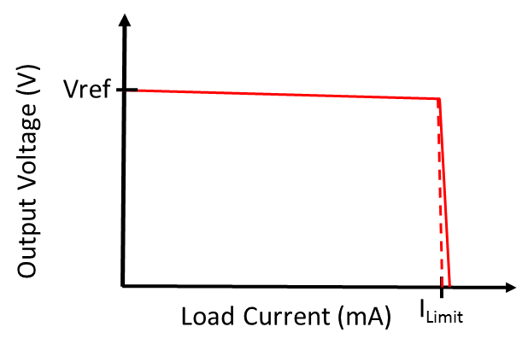Next you are to characterize the output voltage regulation and current limit performance of your DC Output Power Supply and provide a graph of measured output voltage versus load current in the **Measured Voltage regulator Performance** section of your report. Your graph should have the general shape as shown in **Figure 7**, which illustrates a nearly constant (regulated) output voltage until the load current exceeds the current limit. Points will be deducted for graphs illustrating non-functional performance.

**Figure 7:** Output Voltage versus Load Current for a DC Voltage regulator with Current Limit.

To characterize output voltage regulation and the current limit, you are to power your assembled PCB with an AC center-tapped transformer like the one illustrated in **Figure 8.** Connect the Vs1 and Vs2 inputs transformer outputs to your **In1** and **In2** inputs, with the Black transformer center-tap connector connected to **Gnd** of you assembled PCB. circuit board.

**Figure 8:** Center-Tapped Transformers to Power Your DC Output Power Supply.

Next you are to measure and record output voltage of your DC Output Power Supply over a range of load currents. This is to be done by connecting various load resistors between **Vout** and ground and recording the resulting regulator output voltage and current. **For the each of the resistive loads attached to your regulator output, calculate the load current using Ohm’s law utilizing the measured output voltage and the equivalent load resistance value.** **This Ohm’s Law approach to determine the load current is preferred over measuring the current with a series ammeter, as the ammeter adds an additional series resistance.**

Most of the standard available resistors in STC-215 are only rated for 0.25 W, which is likely insufficient to fully characterize your DC Output Power Supply using load resistance values ≤ 100 Ω. For example, the maximum voltage V corresponding to a resistor power dissipation of 0.25 W for a 100 Ω load equals 5.0 V from the relationship P = V2/R. Consequently, 100 Ω, 33 Ω and 22 Ω power resistors (≥ 1.0 W) are available for characterizing your voltage regulator with load resistances ≤ 100 Ω. Alligator clip test leads along with separate alligator clips to combine resistors, as illustrated in **Figure 9** below, are to be used to provide various power resistor combinations to characterize your power supply for load resistances ≤ 100 Ω.

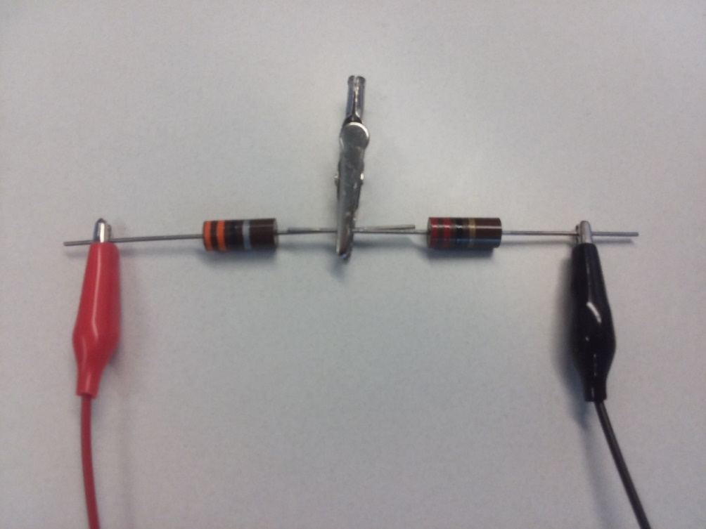

**Figure 9:** Illustration of Connecting a 33 Ω Power Resistor in Series with a 22 Ω Power Resistor to provide a 55 Ω Load.

Load current values of approximately 30%, 60%, 90% and 100% of your current limit value are needed to complete **Table 2** below. You are to first calculate load resistance values resulting in approximately 30%, 60%, 90% and 100% of your recalculated current limit value Icalc, then choose appropriate available resistor as load resistors for testing those data points. Choosing available resistor values that are within ±15% of your calculated values is sufficient for this characterization. For example, for a 5 V regulated output voltage and Icalc = 140 mA, a load resistance value of (5 V)/(140 mA) = 36 Ω would result in 100% of Icalc. Yet a 36 Ω power resistor is not available in STC-215, whereas a 33 Ω power resistor is. So using the available 33 Ω power resistor is sufficient for the 100% of Icalc data point in this particular example, since 33 Ω is within approximately -8% of 36 Ω.

Replace the text in the RLoad column of **Table 2** below with your actual load resistance values and use those values to calculate Iload. Also included in **Table 2** are two load resistance values intended operate your power supply in current limit. Use a 22 Ω, along with two parallel 22 Ω resistors to form an 11 Ω resistor for your last two entries in **Table 2**.

**Table 2**: Output Voltage Regulation and Current Limit Data.

|  |  |  |
| --- | --- | --- |
| Measured Vout(V) | Rload (Ω) | Iload= Vout/Rload (mA) |
|  | ∞ (Open-Circuit) |  |
|  | ≈30% of Calculated Current limit Icalc. |  |
|  | ≈60% of Calculated Current limit Icalc. |  |
|  | Power Resistors: ≈90% of Icalc. |  |
|  | Power Resistors: ≈100% of Icalc. |  |
|  | Power Resistor: 22 Ω. |  |
|  | Power Resistors: 22 Ωǁ22 Ω = 11 Ω. |  |

Your chosen load resistance for ≈90% of Icalc will be needed for the voltage ripple and ripple rejection measurements to be done next.

### Voltage Ripple and Ripple Rejection

Next you are also to characterize 120 Hz ripple rejection performance of your DC Output Power Supply using the VirtualBench oscilloscope, with the AC power coming from a center-tapped transformer shown in **Figure 8** above. The full-wave rectification of the 60 Hz signal, results in a 120 Hz ripple on Vfiltered. A useful figure-of-merit for voltage regulators is ripple rejection and can be quite good (large) at 120 Hz. A good voltage regulator responds fast enough to greatly reduce the 120 Hz peak-to-peak output voltage ripple compared to the ripple voltage on the regulator input. **Since ripple voltage from your full-bridge rectifier circuit increases with increasing load current, a measurement of ripple rejection depends upon load current, and is to be done at approximately 90% of your re-calculated current limit value**.

Using a 2-channel oscilloscope, the ripple rejection of your completed DC Output Power Supply is to be measured when AC powered by the center-tapped transformer with ILoad ≈ 0.9Icalc. The 2-channel oscilloscope is to be used to determine peak-to-peak input voltage ripple, i.e., ∆Vfiltered, along with the peak-to-peak output voltage ripple, i.e., ∆Vout. Since ∆Vfiltered/∆Vout should be much greater than 1 for a properly performing voltage regulator, Ripple Rejection should be a positive number. After measuring ∆Vfiltered and ∆Vout, the ripple rejection is to be calculated as follows:

∆Vfiltered and ∆Vout can both be viewed simultaneously on the oscilloscope by using two channels, with the larger ∆Vfiltered channel for the trigger. Note: Connect the oscilloscope ground leads directly to your PCB ground header pins to minimize lead inductance associated with the oscilloscope probes for this sensitive output ripple measurement. Also select **Noise Reject** as a triggering option in the trigger settings, which helps stabilize the displayed waveform. For both ∆Vfiltered and ∆Vout, AC coupling is necessary to remove the large DC voltages, therefore allowing for improved vertical resolution. By utilizing AC coupling on the VirtualBench 2-channel oscilloscope, small AC ripple on ∆Vout can be viewed on a 10 mV/Division input range utilizing a 1X oscilloscope probe and associated input channel setting. The following waveforms illustrate VirtualBench oscilloscope measurements of ∆Vfiltered and ∆Vout of a properly constructed DC Output Power Supply using a 10X probe for ∆Vfiltered (Red) and a 1X probe for ∆Vout (Yellow).

**Figure 10:** Input Voltage Ripple Measurement of a DC Output Power Supply. Cursors Set to Measure ∆Vfiltered on Channel 1 (Red), resulting in ∆Y = ∆Vfiltered = 866 mV pk-pk.

The ∆Vout ripple on this properly constructed DC Output Power Supply performance illustrated in **Figures 9 & 10** is < 1 mV peak-to-peak, making it difficult to accurately measure. **Figure 11** illustrates the ∆Vout peak-to-peak measurement utilizing the voltage cursors available with the VirtualBench oscilloscope. Measurement averaging on the VirtualBench 2-channel oscilloscope was invoked by means of an option menu located in the upper right-hand corner for the Mixed Signal Oscilloscope for the waveforms shown in **Figure 11**. Selecting the **Acquisition** option, provides averaging options with **128 averages** recommended for this ripple rejection measurement to reduce random measurement noise.

**Figure 11:** Output Voltage Ripple Measurement of a DC Output Power Supply. Cursors Set to Measure ∆Vout on Channel 2 (Yellow), resulting in ∆Y = ∆Vout = 503 µV pk-pk. Noise Reduced on Channel 2 (Yellow) by Averaging 128 Measurements.

Based on the above measured ∆Vfiltered and ∆Vout values, a ripple rejection number of is calculated for the DC Output Power Supply performance illustrated in **Figures 9 & 10**. This is a factor of (866 mV)/(503 µV) = 1722, indicating that the op-amp greatly rejects the 120 Hz ripple on Vfiltered.

After successfully characterizing and calculating the ripple rejection of your DC Output Power Supply, include your calculated ripple rejection in dB in **Table 3** below. **Also include an oscilloscope screen capture of your measured output voltage ripple at approximately 90% of your current limit, like the one illustrated in Figure 11 above with the cursors set to measuring the peak-to-peak output voltage ripple**. For this measurement utilizing waveform averaging and a 1X probe, in the **Measured Voltage regulator Performance** section of your report, including a figure number and caption. Your screen capture should be wide enough to include the CH. 1 and CH. 2 settings control so that a 1X probe setting can be verified for the displayed output voltage ripple.

In addition to your output voltage versus load current graph and ripple rejection, you are to further characterize the performance of your DC Output Power Supply by completing the measurements and calculations listed in **Table 3** below. Replace the valid ranges given in blue in **Table 3** with your specific measured values, including your completed **Table 3**, along with a table number and caption, in the **Measured** **Performance** section of your report.

For your measured current limit value, refer to your graph of measured output voltage versus load current and estimate the minimum current that causes the voltage regulator output to decrease below the desired regulated value. This can also be described as the knee of the output voltage versus load current graph. Determine the percent error between your measured current limit value and your Icalc value based on the actual resistor value used for R5, entering your calculated value in **Table 3**.

# Performance Summary

Replace the ranges of measured values in **Table 3** below with your actual measured values. Include your updated **Table 3** values with your measured performance parameters in the **Measured Performance** section of your project report. Replace the valid ranges given in blue in **Table 3** below with your specific measured values.

**Table 3**: Measured Voltage regulator Performance Parameters.

|  |  |
| --- | --- |
| **Parameter** | **Measured Values** |
| Minimum DC Input Voltage that turns on the LED Indicator (V). | 13.6 V |
| Measured Current Limit Value Imeas (mA). | 100 mA< Icalc < 200 mA |
| Percent error between measured and calculated current limit value, with % Error = (100)(Imeas – Icalc )/(Icalc). | Within ±20% of Icalc using actual R5 value |
| Calculated input voltage ripple for ILoad = 0.9Icalc. | ≤ 2.0 V pk-pk |
| Measured input voltage ripple (∆Vfiltered) for ILoad ≈ 0.9Icalc. (Vpk-pk). | ≤ 2.0 V pk-pk |
| Measured output voltage for no external load. (V). | Vref ±10% |
| Measured output voltage for ILoad = 0.9Icalc. (V) | Vref ±20% |
| 120 Hz Ripple Rejection in dB for ILoad = 0.9Icalc. | ≥ 40 dB |

# Project Report

A future employer or coworker may very well read your project report, so write it with that audience in mind. This implies not boring the reading with an overabundance of figures and verbiage, while also not neglecting important details, such as how the current limit circuitry works. A good report will include all the sections mentioned below and will utilize figure and table numbers and captions along with complete and grammatically correct sentences with correct spelling and punctuation. **Do not include bullet points from the grading rubric or any other text from this instruction document in your project report as that is not professional**.

**Cover Page**: Include class, Project title, and author.

**Introduction**: Introduce your project using more than one sentence to concisely inform readers what it is you designed and constructed. These brief introductory sentences are to be followed by a list of specifications for your project that includes the bullet point items below with the actual output voltage and current limit values for your project. Consider this specification list as a short summary of features as would be included in a sales brochure.

* **AC or DC powered.**
* **Resulting DC Output Voltage.**
* **Current Limit value for overload protection.**
* **LED Power On indicator.**

**Theory of Operation**: Your Theory of Operation should include the following explanations in your own words: (Do not include the following bullet points items in your report.)

* Purpose of diodes D1 and D2 along with capacitor Cf.
* Purpose of diodes LED D3, resistor Rbias1, and Zener Diode DZ1.
* Purpose of the LM385 2.5 V Voltage Reference Diode and op-amp U1-A.
* How resistor R5 and npn transistor Q1 together limit the current through M1 to the desired current limit value.
* How op-amp U1-B along with MOSFET M1 produce a regulated output voltage.

Explaining how the various circuits of your project work in your own words is an opportunity to demonstrate your technical understanding to others, including future employers.

**Your explanatory text is to be authored by you and not be a copy of someone else’s work, including explanatory text pulled from this document**.

In addition, your **Theory of Operation** section is to **include an LTspice schematic diagram of your complete circuit**, including all component values, along with your name annotated to your schematic, **using the Text option available in the Edit pull-down menu in LTspice.** Include component types such as 1N4007 for the rectifier diodes, LM358N for the op-amp IC, and LM385-2.5 for the 2.5 V voltage reference.

For the Zener diode in the LED indicator circuit, document on your schematic the Zener breakdown voltage you used for the Zener diode, such as 10V or 12V, since specific Zener diode part numbers don’t clearly denote the associated Zener breakdown voltage. Similarly, include the color of the indicator LED you choose for LED component type.

**You don’t need to include the test points, op-amp pin numbers, or Drain, Gate and Source labels shown in Figure 4 for your power supply schematic but** **do need to include your name on your overall LTspice schematic of your DC Output Power supply included in your final report, using the Text option available in the Edit pull-down menu.** All figures and tables in your report should include a figure or table number and caption.

**Measured Performance**: Include a section in your project report for measured performance that includes the following items:

* Measured output voltage versus load current graph, including data points for no load, and for ILoad ≈ 0.9Icalc. Include a figure number and caption, along with axis labels and appropriate units.
* **Table 3** completed with Measured and Calculated Values including units along with a table number and caption. (See **Table 3** in the Performance Characterization section of this document for the eight necessary values to include.)
* Oscilloscope screen capture of **output voltage ripple measurement** with input voltage ripple, i.e., Vfiltered, also displayed. The output voltage ripple is to be measured at 0.9Icalc with the cursors indicating the peak-to-peak output voltage ripple value used for your ripple rejection calculation. Include the CH. 1 and CH. 2 settings control so that a 1X probe setting can be verified for the displayed output voltage ripple.

**Discussion and Conclusions:** Include a section in your project report for Discussions and Conclusions that includes a photograph of your completed power supply project, along with appropriate figure number and caption. Also include at least 2 sentences summarizing the simulated power supply project, lessons learned, future improvements, etc.

### Project Report Grading Rubric

|  |  |
| --- | --- |
| **Report Item** | **Points** |
| **Cover Page**   * Include class, Project title and author. | 2 |
| **Introduction**   * Project introduction of at least two sentences. (4 points.) * Specifications. AC/DC powered (1 point), DC Output Voltage (1 point), Short-Circuit protected including current limit value (1 point), LED Power On Indicator (1 point.) | 8 |
| **Theory of Operation (TOP):**   * Purpose of diodes D1 and D2 along with capacitor Cf. (3 points.) * Purpose of LED D3, resistor Rbias1, and Zener diode DZ1. (3 points.) * Purpose of the LM385 Voltage Reference Diode and op-amp U1-A.   (4 points.)   * How resistor R5 and npn transistor Q1 together limit the current through M1 to the desired current limit value. (6 points.) * How op-amp U1-B along with MOSFET M1 provide a regulated output voltage. (6 points.) * Schematic diagram of your complete circuit including component values along with Figure Number and Caption and your name. (11 points total, 3 points for complete schematic, 1 point each (5 points total) for component values for Cf, Rbias2, R1, Rf, and R5. 2 points for Figure number and captions, 1 point for name.) | 33 |
| **Measured Performance:**   * Measured output voltage versus load current graph with figure number and caption illustrating output voltage regulation performance. (8 points, 4 points for reasonable output voltage regulation including functional current limit, 2 points for correctly labeled V versus I axis, 2 points for figure number and caption.) * Reasonable **Table 3** values (See **Table 3** in the Performance Characterization section of this document for the eight necessary values to include. (9 points total with 8 points for values and 1 point for Table number and caption. 1 point per entry. -0.25 points per entry for missing units.) * Output voltage ripple measurement screen capture including AC input coupling, 1X probe and 10 mV/Div setting for output channel, proper cursor settings for output ripple measurement, along with figure number and caption. (8 points, 1 point for AC coupling, 2 points for reasonable input ripple waveform indicating proper loading and reasonable agreement with calculated input ripple value, 1 point for proper cursor measurement for output ripple, 1 point for 1X probe setting, 1 point for 10 mV/Div setting for output channel, 2 points for figure number and caption.) | 25 |
| **Discussion and Conclusions**:   * Photograph of completed project including figure number and caption.   (6 points total, 2 points for figure number and caption.)   * At least 2 sentences summarizing the simulated power supply project, lessons learned, future improvements, etc. (2 Points.) | 8 |
| Grammar and Professionalism | 4 |
|  |  |
| Total | 80 |